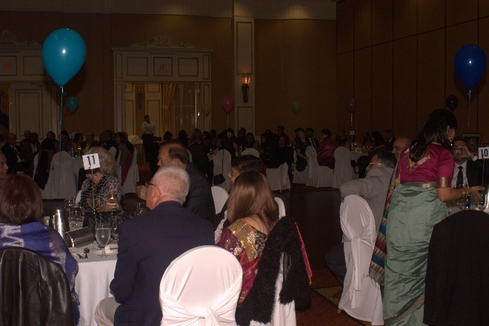

TCF held its 10th Annual Gala Dinner on Friday November 18th at the Hilton Garden Inn, Vaughan. The evening was a celebration of TCF’s fundraising efforts this year and was a great success, with all who attended. Proceeds from this fundraising dinner will go to the charities which TCF runs in Calcutta, India as well as the work it does supporting Women’s Habitat here in Toronto.
After an introduction by the President, Mr. Mihir Ray, the MC’s Sujoy Chatterjee and Ziad Yehia took over the mike and livened up the evening.
Sanskruthi Marathe, Nandita Dias and Tricia Roy mesmerized the audience with dance and music.
Ms. Karlyn Percil-Mercieca, founder of Sistertalk, motivational speaker, life coach and entrepreneur, spoke eloquently for the cause of empowering womanhood and encouraging women in leadership roles.
The keynote speaker, Mr Joe Li, Regional Councilor for the Markham and York region, was interviewed by Sujoy Chatterjee and shared many valuable and motivational ideas ranging from youth leadership to serving the community and country in more meaningful ways.
Dr. Tapas Mondal of McMaster University spoke about the McMaster Cardiopulmonary Resuscitation (CPR) initiative. The initiative is meant to raise awareness about CPR training.
Our kind sponsors Questrade Wealth Management and Sunlife Financial made presentations informing guests of services offered by these companies.
TCF’s Manoshi Chatterjee brought the whole spectrum of TCF’s charitable efforts to life through a presentation which gave the guests a detailed look at the work that TCF does. Guests had a chance to see and understand why TCF is such a deserving candidate for their donations this year and in the coming years.
Dinner was a gourmet affair created by Cuisine of India. It gave an opportunity for longtime friends and supporters of TCF to mingle with newer attendees. The MC’s exhorted all to open their hearts and so they did.
Due to the generosity of TCF’s wonderful sponsors and guests, the total funds raised exceeded 50K, which was applauded by one and all.
The Gala Dinner was a resounding success, thanks to all who organized and participated in this worthy event.

